American FactFinder2 Self Tutorial
Means of Transportation to Work – 2010 ACS

Notes on AMERICAN FACTFINDER 2: http://factfinder2.census.gov courtesy of Linda Clark, US Census Bureau and modified by Elaine Murakami, FHWA (November 22, 2011) for 2010 ACS Table B08301, “Means of Transportation to Work.”

Example 1: I want to get the percent of people biking to work in the Pittsburgh City, PA. Table B08301 from the American Community Survey includes the most detail, including bicycling as a separate category.

Type in “B08301” in the Quick Start box; then select “GO” in the gray box.

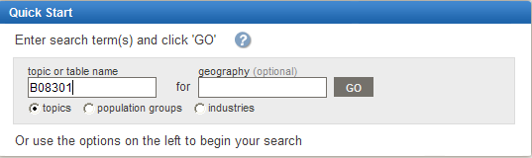

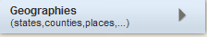
Open Geographies in left navigation bar.
The Geography selection pane will open
in the middle of your screen .

Type in the name of the area you are looking for, and then press the GO box (Gray).
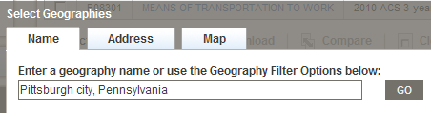

In the Geography Results pane, find and check the box “Pittsburgh city, Pennsylvania” and
CLICK ADD (to move this selection up into Your Selections box). IMPORTANT! If you don’t click “ADD”, geography area won’t be selected. Close Geographies by clicking on "X" in upper right of Select Geographies frame.
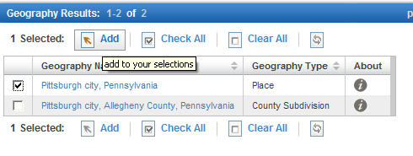

Both 2010 ACS 1-year estimates and 2010 ACS 3-year estimates have the table B08301. Select 2010 ACS 1-year estimate. Then select “view”.
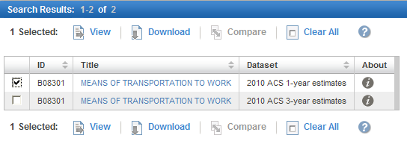

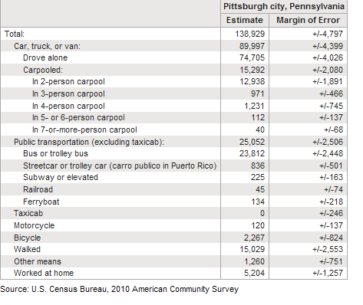
The ACS provides an estimate and the margin of error. To calculate the percentage of bike commuters, divide number of bike commuters by the total number of workers at work.

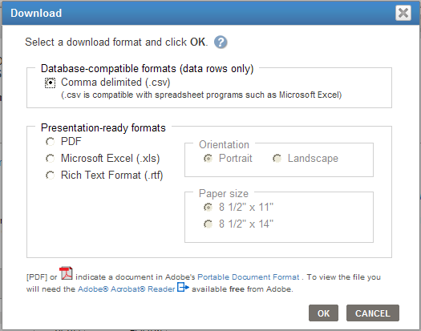
Another choice in the list of Actions is “Download”. You can choose a comma-delimited .csv; .xls, or .pdf. Save the .zip file to your computer, and then unzip it. Note: You may want to download the data in CSV format as tables in Excel format are not in numeric format and all numbers are in character format, 