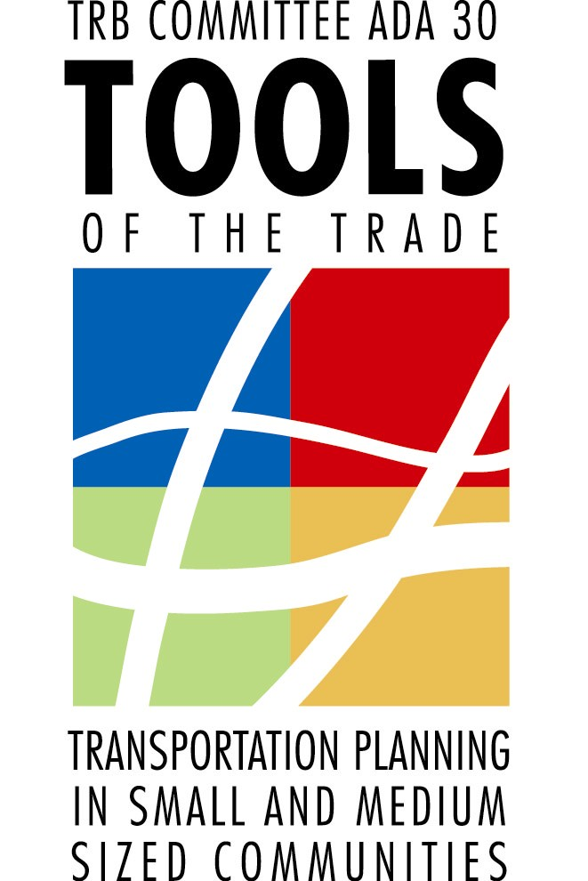
CALL FOR ABSTRACTS
(Submission deadline: October 1, 2011)

13th NATIONAL CONFERENCE ON TRANSPORTATION PLANNING FOR SMALL AND MEDIUM-SIZED COMMUNITIES

"TOOLS OF THE TRADE"
http://www.trbtoolsofthetrade.org/

Tools of the Trade is a national conference providing practical techniques for transportation professionals in small (under 50,000) and medium – sized (50,000 - 250,000) communities. You are invited to participate.

SEPTEMBER 12-14, 2012

Big Sky, Montana

Sponsored by: Transportation Research Board Committee ADA30 “Transportation Planning for Small and Medium-Sized Communities,” the Federal Highway Administration, the Federal Transit Administration, and the Montana Department of Transportation.

The Committee seeks exceptional papers or presentations on transportation planning topics and tools that are applicable to small and medium-sized communities, including:

- Environmental Issues – NEPA, tribal, historical issues, environmental justice  - Financial Strategies – cost estimates, asset management, innovative financing, local funding  - Local Transportation Issues – regional coordination, growth management, linking land use & transportation  - Pedestrian & Bike Planning – ped/bike safety programs, traffic calming, community or corridor bike/ped plans  - Air Quality & Project Planning – project development process, emission inventories/modeling, non-attainment  - Project Programming Process – TIP and STIP development, project evaluation and prioritization, fiscal constraint  - Public Involvement – social media, decision-making, non-traditional stakeholders, visualization | - Reauthorization – new MPO’s, funding, the global economy, climate change  - Rural Transportation – long range plans, rural ITS, safety planning  - Small Urban Systems Planning – corridor studies, multimodal studies, sub area studies  - Technology Sharing – travel demand modeling, data collection & analysis, performance measures, GIS, census data  - Tourism – attraction or special event traffic, way finding systems, alternative modes  - Traffic Operations & Analysis – access management, traffic circulation, safety, maintenance  - Transit Planning – small or rural systems, TOD integration, human services coordination, new starts  - Transportation Logistics – freight, intermodal connectors, hazardous materials
Other topics will be considered. Papers are desired, but not required. Accepted and presented papers will be published in the Conference Proceedings, and authors who meet certain criteria may receive an honorarium of $400.

If you are interested in making a presentation or preparing a paper, please submit an abstract to http://www.trbtoolsofthetrade.org/ by October 1, 2011.

Abstracts will be evaluated based on the following criteria:

Proposal directed toward the special circumstances of small (under 50,000) and/or medium-sized (50,000 – 250,000) communities.

Proposal provides off-the-shelf, economical techniques, which can be readily applied at the local level.
Proposal provides evidence of a successful application in a setting comparable to small and medium-sized communities.

Proposal summarizes work directly applicable to or useful for small and medium-sized communities.

Please submit your abstract to the website submittal link located at http://www.trbtoolsofthetrade.org/

Abstracts will be reviewed by members of the TRB Committee on Transportation Planning for Small and Medium Sized Communities (ADA30). All submitters will be notified of the Committee’s decision by March 2012.

Student Paper Competition
The committee offers a student paper competition highlighting research being conducted by tomorrow’s transportation professionals. Students are encouraged to submit abstracts for consideration. A cash prize of $500 will be awarded for the best student paper.

If you have any questions concerning abstract submittal for the conference, contact:
Walter Jeffery Moore, AICP
Kentucky Transportation Cabinet
Phone: 270-746-7898
e-mail: jeff.moore@ky.gov

If you have general questions about the conference or to be added to the mailing list, contact:
Lynn Zanto
Montana Department of Transportation
Phone: 406-444-3445
e-mail: lzanto@mt.gov

Learn more about the conference and the committee at http://www.trbtoolsofthetrade.org/

