Workshop 118: Institutionalizing Health in Transportation Agency Practice
Sunday 1/10/2016, 9:00 AM to12:00 PM
156, Convention Center

The TRB Health and Transportation Subcommittee will be celebrating its 5th year in 2016. The integration of health in transportation has continued to increase across the United States, and the importance of public health considerations in transportation planning is gaining in acceptance. As awareness of the health impacts of transportation grows, transportation agencies are looking for ways to better understand the connections and tools needed to integrate health in transportation decisions. In support of this, the Subcommittee continues to play a key role in providing a forum for information exchange and sharing of research, tools and best practices as well as identifying new research to advance the field.

Given substantial progress to date, the 2016 workshop builds on this success and will focus on how public health can be institutionalized in transportation agency practice. Key topics addressed will include:
- workforce development and key skills,
- leadership buy in, and
- funding.

The overall objective of the workshop is to help transportation professionals incorporate health into their agencies' work through four examples of how this has been done by other organizations around the country. By the end of the day, attendees will be able to identify at least one strategy for institutionalizing health in their work, which has the potential to work in their state/local context. In addition, attendees will be able to identify at least three new tools and resources for accomplishing this goal.

The workshop features transportation agencies and where possible their public health counterparts from around the country, as well as national organizations that are providing key resources for these initiatives. Participants will share practices and lessons learned on how to jump start pilot or short-term grant funded initiatives that can be leveraged and grown into longer-term programs to integrate public health into transportation decisions.

The format will begin with state, regional and local case studies, followed by an introduction to some key national resources for jurisdictions that want to take their practice to the next level. The workshop will conclude with a lightning round for information sharing and discussion. Audience participation encouraged.

Sponsored by:  - Environmental Justice in Transportation (ADD50)  - Urban Transportation Data and Information Systems (ABJ30)  - Transportation Planning for Small and Medium-Sized Communities (ADA30)  - Traveler Behavior and Values (ADB10)  - Transportation and Sustainability (ADD40 | 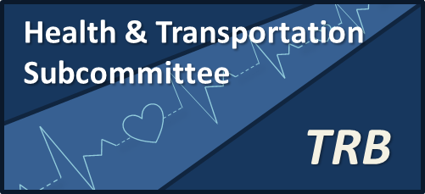

Presiding: Ed Christopher, MKC Associates
Volunteers to Help with Workshop:
Amy Ingles: Unaffiliated (Notetaking) and Sean Co: Toole Design Group

Session Introduction: 20 minutes (allowing time for the room to get settled, introductions, etc.) Ed Christopher,

Transportation and Health Partnerships
Case Studies: 90 Minutes (15 minutes per case study with 5 minutes Q &A after each, plus 10 minutes for wrap up Q & A at the end)

Tennessee and Nashville: 20 Minutes
Leslie Meehan, Tennessee Department of Health
Rochelle Carpenter, Nashville MPO

Delaware Valley, Philadelphia Region:20 Minutes
Alison Hastings, Delaware Valley Regional Planning Commission,

Clackamas County, Oregon: 20 Minutes
Joe Marek, Clackamas County Department of Transportation and Development and Clackamas County Safe Communities,

San Francisco 20 Minutes
Chava Kronenberg, San Francisco Municipal Transportation Agency
Devan Morris, San Francisco Department of Public Health

Break: 15 minutes

National Resources 30 minutes

Centers for Disease Control: Ken Rose and/or Geoffrey Whitfield

FHWA Health Framework: Beverly Bowen, ICF International

Robert Wood Johnson Foundation: Sharon Roerty

Health Impact Project: Rebecca Morley and/or Emily Bever

American College of Sports Medicine: Janet Rankin

Information Sharing, General Q&A and Discussion with audience participation 20 minutes

